Assignment 6

Question 1 = Write two different queries that would produce all orders taken on October 3rd or 4th , 1990.

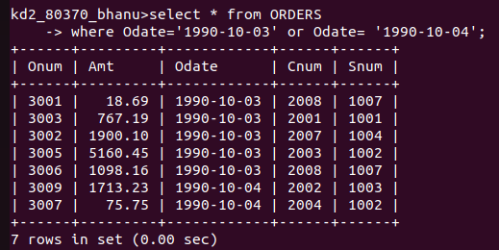

Question 2 = Write a query that selects all of the customers serviced by peel or motika.
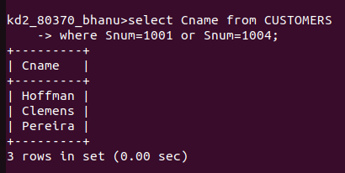

Question 3. Write a query that will produce all the customers whose names begin with a letter from ‘A’ to ‘G’

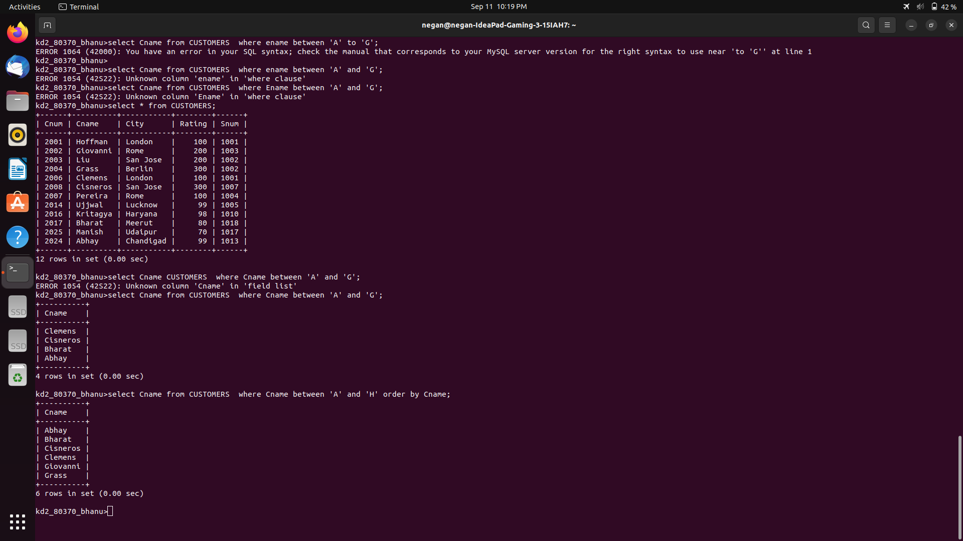

Question 4. Write a query that selects all the customers whose names begin with the letter ‘C’.

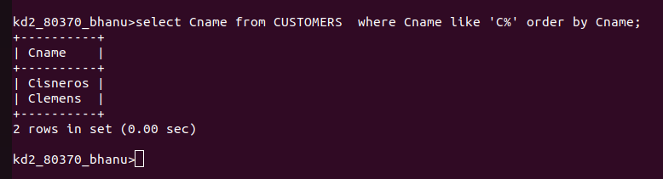

Question 5. Write a query that selects all order except those with zeroes or nulls in the amt field.

